Sample

**Project Scope Document**

Project Name: - Food Delivery Android Application

Submitted By: -

Sweety J.R.Patil

Table of Contents

1. Modules 3
   1. Admin Module 3
   2. Customer Module 4
2. Key Features 4
   1. Front-Desk Operations 4
   2. Reports Management 5
   3. Discount Management 5
   4. Customer Data Management 6
3. Technology & Framework 6
   1. Android Version 6
   2. Database 6
   3. Language 6

# Modules

## Admin Module

Admin can access the mobile application at the back-end and can perform below mentioned activities:

1. Create login
2. Add, update and delete anything (restaurants availability, prices) he wants to change
3. Can access the data of customer such as name, address or contact information
4. Check the customer’s order information and their payments
5. Checks the history of delivery boys.



## Customer Module

A customer has limited front-end access to make the orders and will be able to perform below mentioned activities:

1. Register as a customer in the application
2. Login using customer ID and Password or can login as a guest to get directed to the search menu of the application
3. Check the types of foods availability.
4. Do the payment in different modes(cash or online) to make the order
5. Can order food for anyone in their name.
6. Check the coupons and discounts.
7. Cancel the order and can ask for refund according to the hotel’s policy.
8. Give feedback for the food.



# Key Features

## 2.1Front-Desk Operations

|  |  |
| --- | --- |
| In-Scope | Out-Scope |
| 1. Check order details. 2. Assign orders to the respective hotels. 3. Accept online payments 4. Issue receipts via email or through customer account 5. Add, edit bill according to the orders. | 1. Additional requests 2. Auto update of Add-ons 3. Advertising |

## 

## 2.2 Reports Management

|  |  |
| --- | --- |
| In-Scope | Out-Scope |
| 1. Daily Order report 2. Capacity utilization report 3. Tax report 4. Revenue Report 5. Customer query resolution report | 1. Customer Order Cancel Report 2. Discount on Particular Food Report. 3. Hotel Cancel Food Report. |

## 2.3Payment Management

|  |  |
| --- | --- |
| In-Scope | Out-Scope |
| 1. Imparting payment-gateway 2. Secure payment processes | i. Auto-refund after cancelation of order. |

## 2.4 Discount Management

|  |  |
| --- | --- |
| In-Scope | Out-Scope |
| 1. Exclusive rates and rewards for regular customer 2. Seasonal discounts 3. Provide Promo codes | i. Referral discounts |

## 2.5 Customer Data Management

|  |  |
| --- | --- |
| In-Scope | Out-Scope |
| 1. Organized customer information 2. Customer’s bill and payment information 3. Customer data security 4. Feedback management features | i. Customer analytics dashboard |

# 3. Technology & Framework

## 3.1Android Version

The application is compatible to android 7.0+

## Database

Oracle RDBMS 18.1.0 will be used to store the data and retrieve related information

## 3.3 Language

Java SE 10 will be used for programming the application.

# Proof of Concept

Mock-ups for Food Delivery App

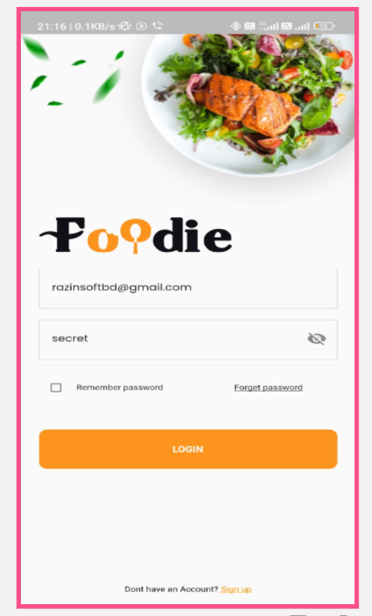



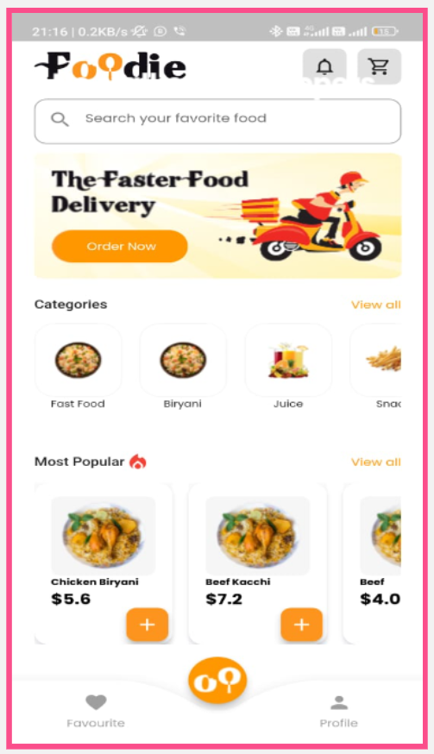



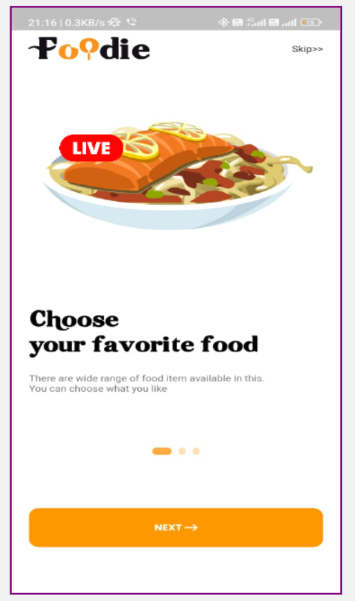



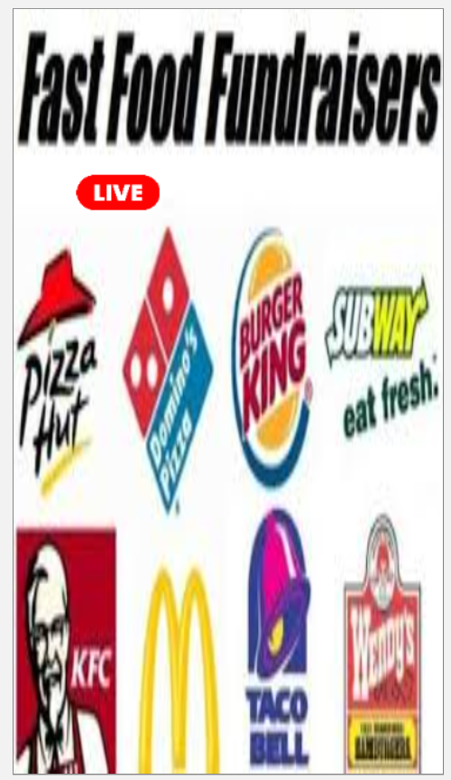



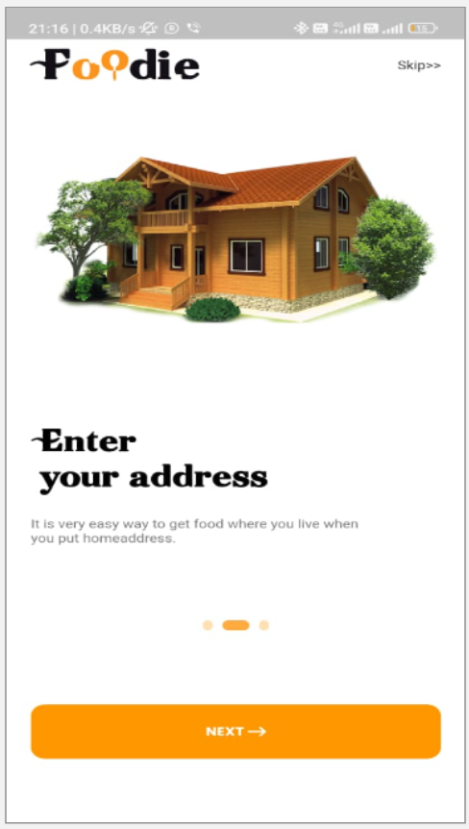



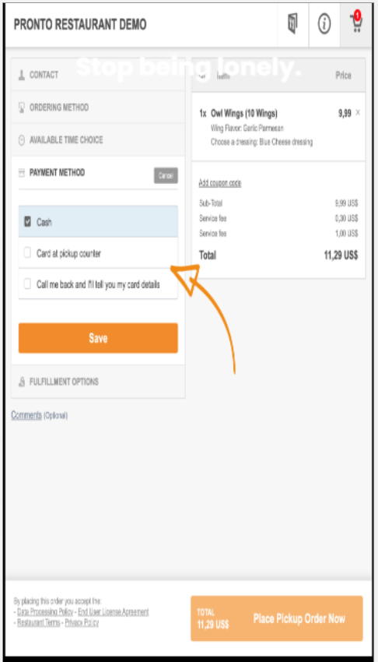



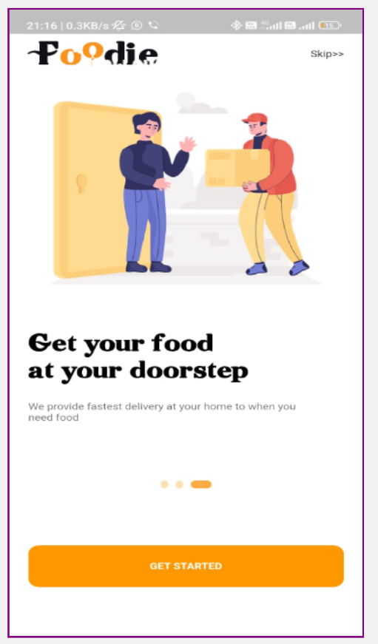

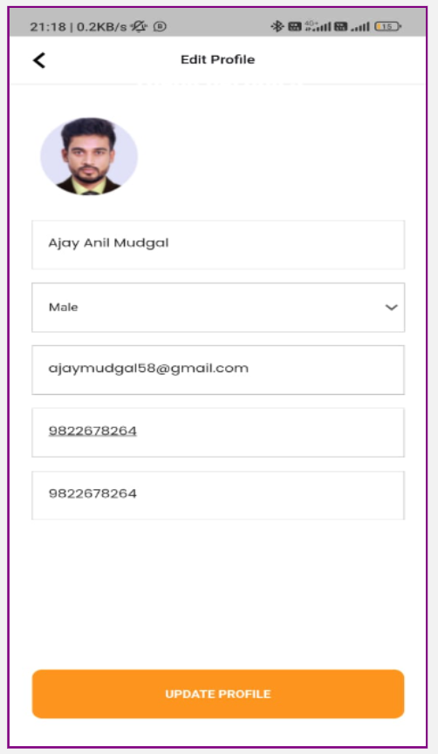

Project Estimation

**Project Estimation: Admin Portal**

|  |  |  |  |
| --- | --- | --- | --- |
| **Module** | **Features** | **Back end (hours)** | **Front end (hours)** |
| Basic Setup | * Configuring AWS environ * Design database schemes * Code repository setup | 10  10 | 0  0 |
| Account | * Database table design * Admin login * Forgot password * Update data | 5  5 | 10  10 |
| Sitting | * Add, view and edit hotel details and delivery boys login IDs. * Add, Update, delete restaurants coupons, etc. | 5  5 | 5  5 |
| Customer Details | * Search customer details * Add, view customer information * View customers order details | 5  5 | 5  5 |

**Project Estimation: Customer Portal**

|  |  |  |  |
| --- | --- | --- | --- |
| **Module** | **Features** | **Back end (hours)** | **Front end**  **( (hours)** |
| Account | * Database table design * Register customer * Enter customer details * Login * Forgot password | 7  7 | 5  5 |
| Order | * food availability in different restaurants * Enter customer details * Order the food and make payments * Cancel the orders | 5  5 | 5  5 |
| Payments | * Review order * Make the payments * Generate online bill for the orders * Check order confirmation * Track the refund after cancellation | 5  5 | 5  5 |
| Feedback | * Give feedback on the services * Raise complaints and track status | 2  2 2  2 | 3  3 |

|  |  |  |  |  |
| --- | --- | --- | --- | --- |
| **No. of Resources** | **Type of Resources** | **No. of days** | **No. of hours/day** | **Total hours** |
| 1 | Backend Developer | 12 | 9 | 108 |
| 1 | Frontend Developer | 12 | 9 | 108 |
| 1 | Database Developer | 5 | 9 | 45 |
| 1 | Tester | 10 | 9 | 90 |
| 1 | Business Analyst | 30 | 9 | 270 |
| 1 | Project Manager | 30 | 3 | 90 |
| 1 | Executive (Support) | 15 | 2 | 30 |

Team Structure

IT team needed for the project to manage and develop the application for food delivery application is as shown in the hierarchical diagram below.

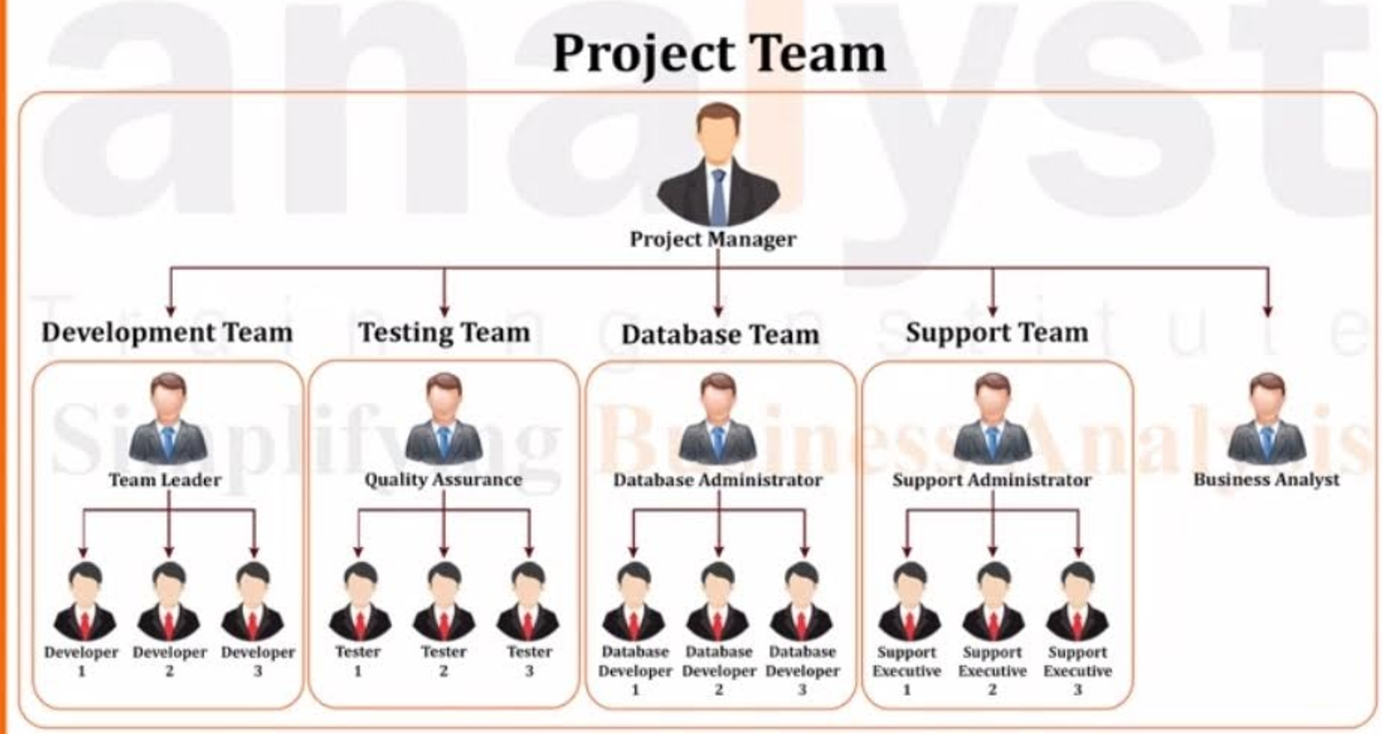

# BRD (Business Requirement Document)

## Problem Statement:

* Physically visit to the hotels.
* For ordering food Customer needs to call the hotels or personally needs to visit to the hotels for taking their food.
* That’s why Customers must have to check the working hours of the hotels.
* Ordering Food at specific time (working hours).
* Customer can only be able to order food at the working hours of the restaurants.
* If Customer wants immediate food delivery, then it not possible.
* No transparency between Customer and Hotels.
* Once the customer takes the meal from the restaurants and lefts the restaurant than it’s not their responsibility to ensure whether the food is fresh or not.
* Customer must believe on restaurants given food.
* Traditional payment methods.
* Restaurants use only traditional payment method (Cash, Bank transfer) so it takes more effort to maintain all records.
* Sometimes it causes some mistakes in accounts records.
* Needs to maintain all previous records in physical space.
* Restaurants needs to maintain all previous records in files, it takes much space.
* There is always the possibility that records will be lose.
* Can’t able to take multiple orders at a time.
* By traditional method restaurants can’t able to take multiple orders at a time.
* Can’t able to take orders from different places.

## Project scope (Goal of Project):

* The aim is to automate its existing manual system by the help of computerized equipment’s and full-fledged computer software, fulfilling their requirements, so that their valuable data/information can be stored for a longer period with easy accessing and manipulation of the same. Basically the project describes how to manage for good performance and better services for the clients.
* Moreover, this system is designed for the particular need of the restaurants to carry out operations in a smooth and effective manner. The application is reduced as much as possible to avoid errors while entering the data.
* It also provides error message while entering invalid data. No formal knowledge is needed for the user to use this system. Thus, by this all it proves it is user-friendly.
* Online Food Ordering System, as described above, can lead to error free, secure, reliable and fast management system. It can assist the user to concentrate on their other activities rather to concentrate on the record keeping. Thus, it will help organization in better utilization of resources.
* Every organization, whether big or small, has challenges to overcome and managing the information of Category, Food Item, Order, Payment, Confirm Order. Every Online Food Ordering System has different Food Item needs; therefore, we design exclusive employee management systems that are adapted to your managerial requirements.
* This is designed to assist in strategic planning and will help you ensure that your organization is equipped with the right level of information and details for your future goals.
* This system will help you to get your food at your door step. Meaning, in this system we will provide a function of food delivery boy who will be responsible to deliver your food at your house.
* It tracks all the information of Category, Payment, Order etc., Manage the information of Category shows the information and description of the Food Item and Customer.

**High-Level As-Is (Existing) Business Process**

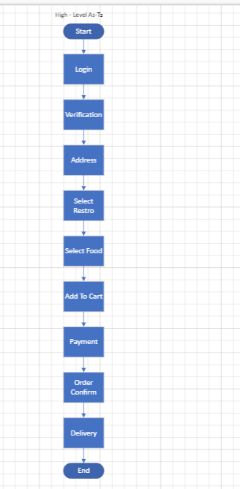

This diagram shows what is flow of process of ordering food in **as- is** process or existing business of food delivery app. In the diagram only two actors are there and they are admin and customer.

**High-Level To-Be**

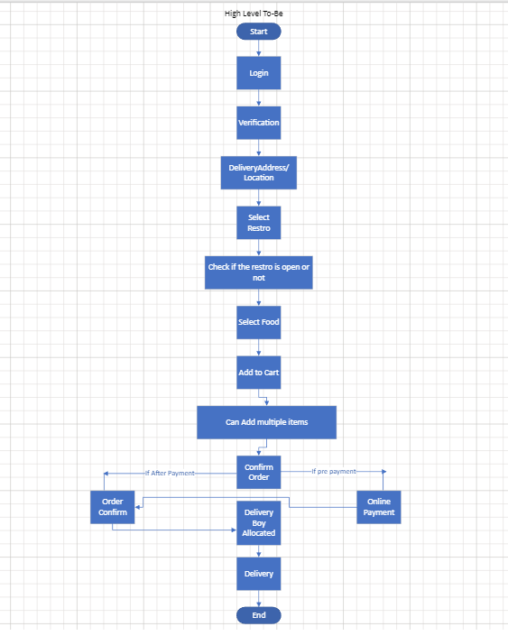

This diagram shows what is flow of process of ordering food in **To- Be** process or existing business of food delivery app. In the diagram only two actors are there and they are admin and customer. Here customer gets two options for payment after they confirms the order(cash on delivery and online payment).

## Functional Requirements

### UI screens

|  |  |
| --- | --- |
| **1**  **Login-Register page**  Put login details or click on any social media which you want or just register with email. | 2  **Home Page**  After Login, home page will come where the customer will able to see different food options. |
| **3**  After home page the customer will able to choose his/her favorite food from different options. | **4**  **Select and add to cart**  After selecting the food customer can put that food in cart for ordering. |
| **5**  **Location /Address**  After selecting the food customer will have to fill the address where they want to the food delivered. | **6**  **Payment**  At the last customer will make payment , customer will have two options like cash on delievery or online payment. |

## Non-Functional Requirements

### UI/UX Requirement

### Static Data

### Hardware Configuration

4 GB ram or more

150 free spaces required.

Location sensors required.

For website, any browser is fine but must have updated version of it.

### Software & Database license

Sql Server.

### Network Requirement

Any network is fine with minimum speed of 5mbps.

### Security Requirement

System must be followed all security laws; all data must be protected in safe servers.

### Performance Requirement

Page opening and changing time should be less as possible, multiple orders from different locations within a same area should not cause a server crash or any glitch.

### Third Party Integration

Payment gateway: G-pay, Amazon Pay, Bhim etc.

## 

## Assumption & Constraints

### Assumption:

1. You will be provided multiple options for login / sign-up
2. You will get add edit remove option for address, in profile.
3. You will able to order food from anywhere.
4. You will be provided multiple options for hotel selection as well as food.
5. Are also able to cancel order (T&C).
6. Also, able to track location of delivery boy.

### Constraints:

1. You must be a registered user for ordering food online.
2. You must select exact delivery location/address.
3. If you want to cancel your order then you must cancel the order before the delivery boy delivers the food at your house.(T&C)
4. You must select the payment mode.

## 

## SRS (Software Requirement Specification)

## Problem statement

* Physically visit to the hotels.
* For ordering food Customer needs to call the hotels or personally needs to visit to the hotels for taking their food.
* That’s why Customers must have to check the working hours of the hotels.
* Ordering Food at specific time (working hours).
* Customer can only be able to order food at the working hours of the restaurants.
* If Customer wants immediate food delivery, then it not possible.
* No transparency between Customer and Hotels.
* Once the customer takes the meal from the restaurants and lefts the restaurant than it’s not their responsibility to ensure whether the food is fresh or not.
* Customer must believe on restaurants given food.
* Traditional payment methods.
* Restaurants use only traditional payment method (Cash, Bank transfer) so it takes more effort to maintain all records.
* Sometimes it causes some mistakes in accounts records.
* Needs to maintain all previous records in physical space.
* Restaurants needs to maintain all previous records in files, it takes much space.
* There is always the possibility that records will be lose.
* Can’t able to take multiple orders at a time.
* By traditional method restaurants can’t able to take multiple orders at a time.
* Can’t able to take orders from different places.

## Project Scope (Goal of Project):

* The aim is to automate its existing manual system by the help of computerized equipment’s and full-fledged computer software, fulfilling their requirements, so that their valuable data/information can be stored for a longer period with easy accessing and manipulation of the same. Basically the project describes how to manage for good performance and better services for the clients.
* Moreover, this system is designed for the particular need of the restaurants to carry out operations in a smooth and effective manner. The application is reduced as much as possible to avoid errors while entering the data.
* It also provides error message while entering invalid data. No formal knowledge is needed for the user to use this system. Thus, by this all it proves it is user-friendly.
* Online Food Ordering System, as described above, can lead to error free, secure, reliable and fast management system. It can assist the user to concentrate on their other activities rather to concentrate on the record keeping. Thus, it will help organization in better utilization of resources.
* Every organization, whether big or small, has challenges to overcome and managing the information of Category, Food Item, Order, Payment, Confirm Order. Every Online Food Ordering System has different Food Item needs; therefore, we design exclusive employee management systems that are adapted to your managerial requirements.
* This is designed to assist in strategic planning and will help you ensure that your organization is equipped with the right level of information and details for your future goals.
* This system will help you to get your food at your door step. Meaning, in this system we will provide a function of food delivery boy who will be responsible to deliver your food at your house.
* It tracks all the information of Category, Payment, Order etc., Manage the information of Category shows the information and description of the Food Item and Customer.

**Low-Level As-Is**

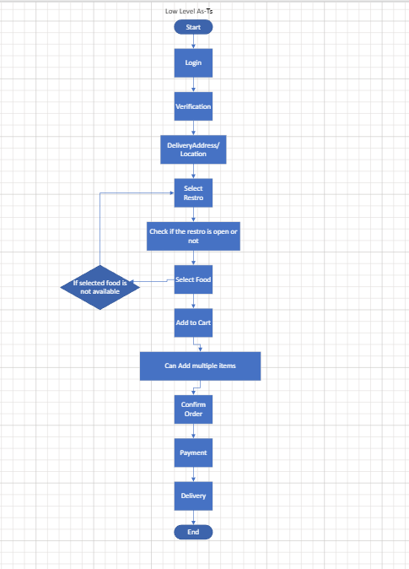

This diagram shows what is flow of process of ordering food in **As- is** process or existing business of food delivery app. In this if the selected food is not available in the selected restaurant than the customer can go back and can select other restaurants.

### Low-Level To-Be

### 

This diagram shows the business flow process of food ordering, in **To-be** process or proposed system of food delivery app. In this proposed system the customer gets multiple options for ordering the food and gets the food delivery at their house.

### Functional Requirement:

### Use Case Specification 1

|  |  |  |  |
| --- | --- | --- | --- |
| **Use Case ID:** | **Ucid001** | **Prepared By** | **Sweety** |
|  | | **Prepared Date:** |  |
| **Use Case Name: New User Can Register** | | | |
| **Use Case Diagram:** | | | |
| **Actors: New User** | | | |
| **Pre-Condition** | | | |
| **1.User Must login** | | | |
| **Successful Post Condition** | | **Unsuccessful Post Condition** | |
| 1. **Show Pop-up window with message**   **“User Registration Successful”**   1. **Click on ‘OK’ Button & navigate to login page** | | 1. **Stay on Registration page** 2. **Show validation message below field name in color ‘Red’ font ‘Arial’ size 10** 3. **Please refer validation message in field validation table** | |
| **Basic Flow** | | **Alternate Flow** | |
| 1. **Click on ‘Register’ link on top right corner of home page** 2. **Fill mandatory fields** 3. **Click on submit button** | | 1. **Click on ‘Register’ link on footer & pre-payment page.** 2. **Fill mandatory fields** 3. **Click on submit button** | |
| **Field Validation Table** | | | |
|  | | | |

|  |  |  |  |  |  |  |  |  |  |  |
| --- | --- | --- | --- | --- | --- | --- | --- | --- | --- | --- |
| **Sr. No** | **Field Name** | **Control Type** | **Data Type** | **Length** | **Default Value** | **Other Value** | **Functional Requirement** | **Business Rule** | **Validation Rule** | **Validation Message** |
| **1** | **First Name** | **Text box** | **Character** | **150** | **Please Enter First Name** | **NA** | **Please Enter First Name** | **NA** | **Mandatory** | **For validation Rule 1 Show below message.**  **“Please Enter First name”** |
| **No space Before/ After/ In Between** | **For validation Rule 2 Show below message.**  **“Please enter First name without space”** |
| **Character Only** | **For validation Rule 3 Show below message.**  **“Please enter character only”** |
|  |  |

### Use Case Specification 2

|  |  |  |  |
| --- | --- | --- | --- |
| **Use Case ID:** | **Ucid002** | **Prepared By** | **Sweety** |
|  | | **Prepared Date:** |  |
| **Use Case Name: User can login** | | | |
| **Use Case Diagram:** | | | |
| **Actors: User** | | | |
| **Pre-Condition** | | | |
| **1.User Must be registered** | | | |
| **Successful Post Condition** | | **Unsuccessful Post Condition** | |
| 1. **Show Pop-up window with message**   **“User login Successful”**   1. **Click on ‘OK’ Button & navigate to food selection page** | | 1. **Stay on Login page** 2. **Show validation message below**   **“‘Username’ or ‘Password’ Not matched”**   1. **Please refer validation message in field validation table** | |
| **Basic Flow** | | **Alternate Flow** | |
| 1. **Fill mandatory fields** 2. **Click on ‘Login’ button instead of register.** | | 1. **Click on ‘Login’ button on account tab or pre-payment page.** 2. **Fill mandatory fields** 3. **Click on submit button** | |
| **Field Validation Table** | | | |
| |  |  |  |  |  |  |  |  |  |  |  | | --- | --- | --- | --- | --- | --- | --- | --- | --- | --- | --- | | **Sr. No** | **Field Name** | **Control Type** | **Data Type** | **Length** | **Default Value** | **Other Value** | **Functional Requirement** | **Business Rule** | **Validation Rule** | **Validation Message** | | **1** | **Username/ Email** | **Text box** | **Character** | **150** | **Please Enter Username/Email** | **NA** | **Please Enter Username/Email** | **NA** | **Mandatory** | **For validation Rule 1 Show below message.**  **“Please Enter Username/Email”** | | **No space Before/ After/ In Between** | **For validation Rule 2 Show below message.**  **“Please enter Username/Email without space”** | | **Only these Symbols** | **For validation Rule 3 Show below message.**  **“Please use only**  **@_.#$! These symbols”** | |  |  | | | | |

### Use Case Specification 3

|  |  |  |  |
| --- | --- | --- | --- |
| **Use Case ID:** | **Ucid003** | **Prepared By** | **Sweety** |
|  | | **Prepared Date:** |  |
| **Use Case Name: User can select food** | | | |
| **Use Case Diagram:** | | | |
| **Actors: User** | | | |
| **Pre-Condition** | | | |
| **1.User Must login** | | | |
| **Successful Post Condition** | | **Unsuccessful Post Condition** | |
| 1. **Show 2 boxes with**   **Restaurants and food category**   1. **Click on ‘OK’ Button & navigate to selected restaurants page for food selection.** | | 1. **Stay on login page** 2. **Show validation message below**   **Selected restaurant or food is not available**   1. **Please refer validation message in field validation table** | |
| **Basic Flow** | | **Alternate Flow** | |
| 1. **Fill Both Restaurants and food category manually** 2. **Click on submit button** | | 1. **Select both fields from given Select food facility.** 2. **Click on submit button** | |
| **Field Validation Table** | | | |
| |  |  |  |  |  |  |  |  |  |  |  | | --- | --- | --- | --- | --- | --- | --- | --- | --- | --- | --- | | **Sr. No** | **Field Name** | **Control Type** | **Data Type** | **Length** | **Default Value** | **Other Value** | **Functional Requirement** | **Business Rule** | **Validation Rule** | **Validation Message** | | **1** | **Restaurants and food category** | **Text box** | **Character** | **300** | **Please select Restaurants and food category** | **NA** | **Please select Restaurants and food category** | **NA** | **Mandatory** | **Please select Restaurants and food category** | | **Food selection is must** | **Please select Restaurants and food category** | |  |  | |  |  | | | | |